**AI-Driven Exploration and Prediction of Company Registration Trends**

**Team member:**

**Saranraj S,**

**CSE-III year,**

**AI101(IBM-Artificial Group1),**

**Team Name: The aesthetic coders,**

**Adhi college of engineering and technology.**

**Problem Definition:**

* The problem entails analyzing company registration data to identify patterns and predictions of registration trends. It involves developing AI models to forecast future registration rates. The objective is to aid stakeholders in making informed decisions for business growth and policy formulation.

**Aim/objective:**

* The project aims to analyse historical company registration data to uncover patterns and trends. It involves building machine learning models for accurate prediction of future registration rates. The ultimate goal is to provide actionable insights for informed business strategies and policy decisions, fostering sustainable growth.

**Design Techniques:**

1. **Data Collection and Preparation:**

* Gather comprehensive historical company registration data, including attributes such as industry sector, geographical location, company size, and registration dates.
* Preprocess the data by handling missing values, outliers and inconsistencies to ensure data quality.

1. **Exploratory Data Analysis (EDA):**

* Conduct EDA to understand the data distribution, relationships and potential patterns.
* Visualize data using graphs, charts and statistical measures to gain insights into trends and correlations.

**3.Featured Engineering:**

* Identify relevant features that can impact company registration trends, such as economic indicators, regulatory changes or industry performance.
* Create new features or transform existing ones to enhance predictive capabilities.

**4.Model Selection and training:**

* Choose appropriate AI models for the prediction task, such as regression models, time series analysis, or deep learning models like neural networks.
* Split the data into training and testing sets, and train the selected models using suitable training techniques.

**5.Hyper Parameter Tuning:**

* Optimize model performance by tuning hyperparameters using techniques like grid search, random search or Bayesian optimization.
* Fine- tune parameters to achieve the best prediction accuracy.

**6. Validation and Evaluation:**

* Validate model performance using a separate validation dataset or through cross-validation techniques.
* Evaluate models using relevant metrices like Mean Absolute Error (MAE), Root Mean Square Error (RMSE) or R- squared to access prediction accuracy.

**7.Visualiation and Interpretation:**

* Develop visualization to showcase predicted trends, model performance and insights derived from the analysis.
* Create interactive dashboard for easy interpretation and exploration of predictions.

**8.Intergration and Deployment:**

* Integrate the trained model into a user -friendly application or platform for accessibility and usability.
* Deploy the model to a production environment, ensuring it can handle real-time prediction requests.

**9.Continous Monitoring and Improvement:**

* Implement mechanisms to monitor performance in a real-world setting and gather user feedback.
* Iterate and improve the model based on new data and emerging trends to enhance prediction accuracy and relevance.

**10.Documentation and Knowledge Sharing:**

* Document the entire project, including data preprocessing steps, model architecture, training methodologies and results.
* Share knowledge and insights gained from the project within the team and the wider community to encourage learning and collaboration.



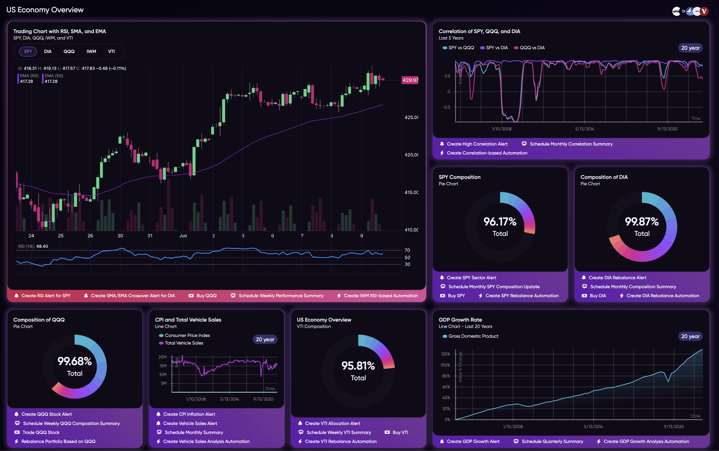

**Conclusion:**

In summary, this project utilizes AI and data analysis to predict future company registration trends. By analysing historical data and building predictive models, it enables informed decision-making for business growth and policy strategies. The project showcases the power of AI in providing valuable insights for a data-driven approach in the business domain.